Subject Line: [School Name] yearbook: Remember What’s Important
Body:
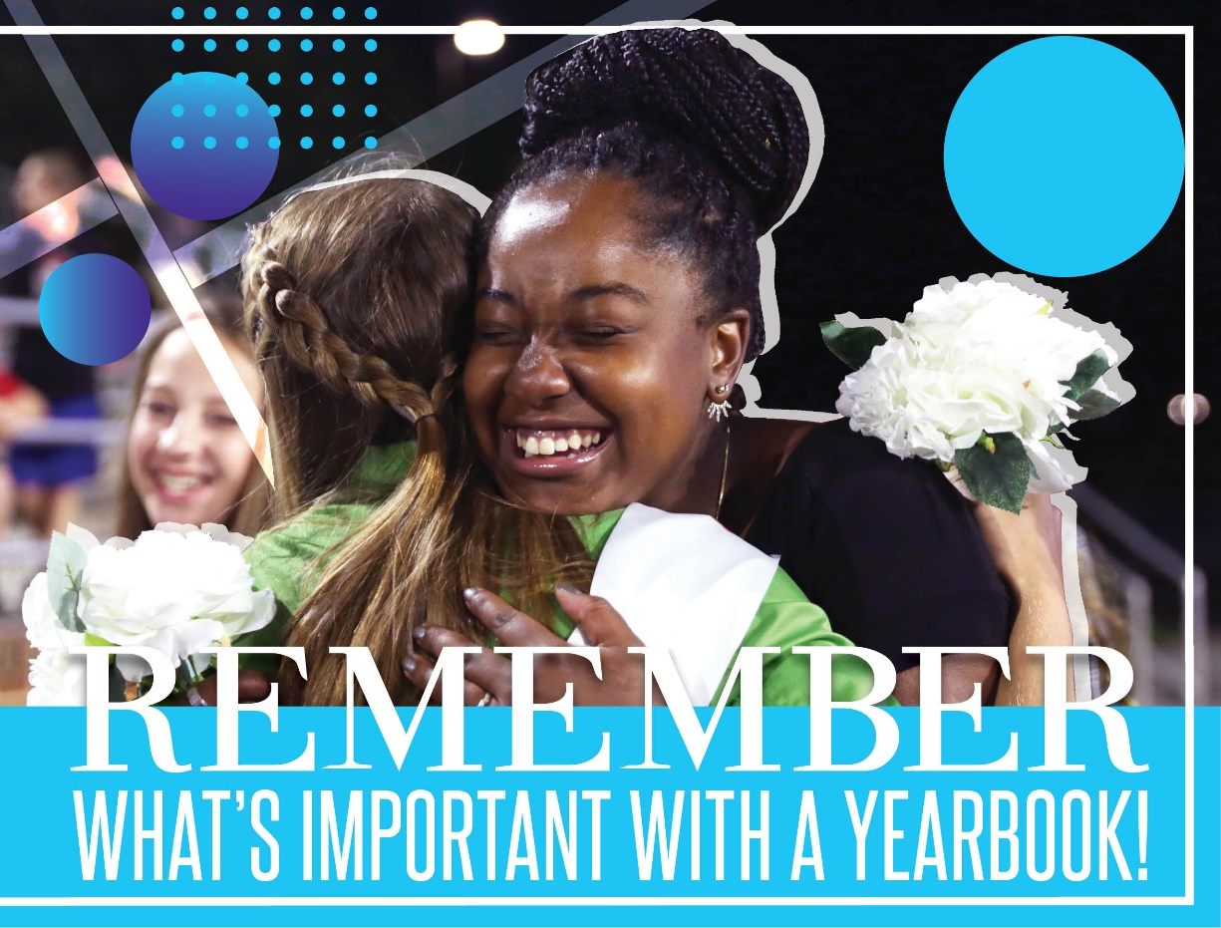
Your student’s time at school mattered. They made friends, learned valuable lessons, created a life for themselves and made many memories. Memories that will be captured inside the pages of the [School Name] yearbook.

The 2019-2020 yearbook is a historic and passion-filled project covering the first day of school to the events unfolding now. Stand with your student and pay tribute to their year by reserving a copy of the [School Name] yearbook today.
Don't wait to purchase at school, with new developments happening daily in the global fight against COVID-19, this may be your only way to order.

